Segmentation and Clustering of NY City and Toronto

**A comparison of Neighborhoods**

Nikhila Anumukonda

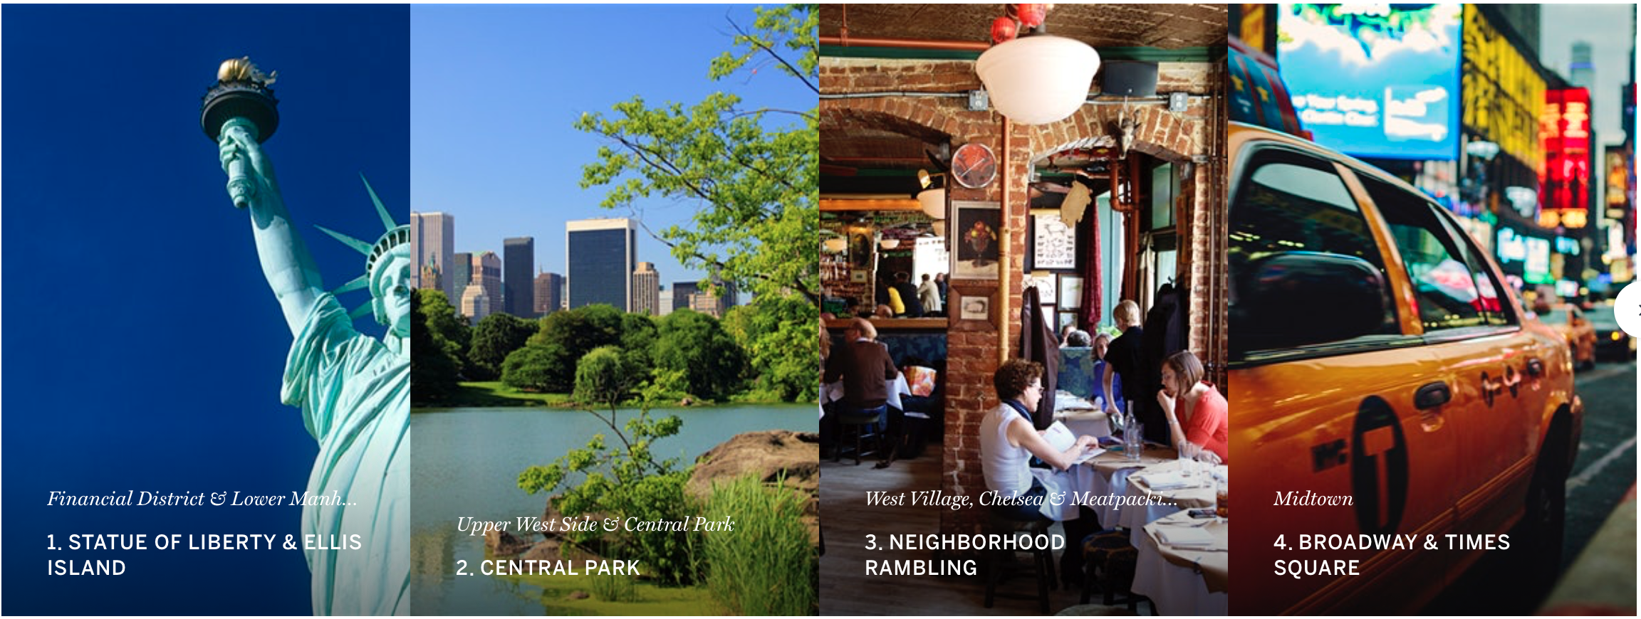

NEW YORK

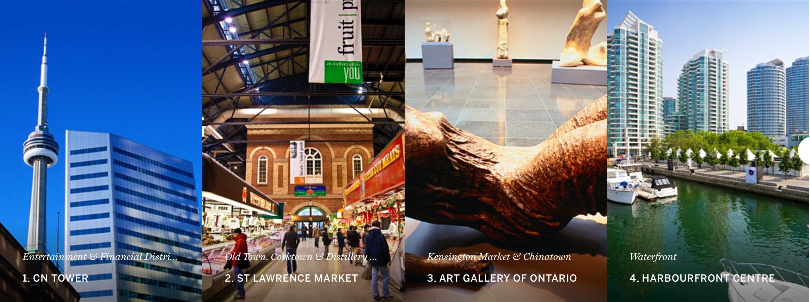

TORONTO

# Data Acquisition and Preparation

In this section, we will discuss the process of data acquisition and preparation of the data for our analysis. There re basically two types of data we will extract and process. The neighbourhood data for New York and Toronto and the Venue data for them.

The Neighbourhood data is extracted from data sources provided by IBM and the Wiki page on the internet. It is then merged with the Geospacial data to get Longitudes and Latitudes of the neighourhoods.

The Venue data is retrieved from Foursquare API which is one of the largest sources of location and venue data.

## Neighborhood and Venue Data for Toronto

**Neighborhood**

For Toronto data, there is a Wikipedia page titled “List of postal codes of Canada: M”. This page lists the postal codes in Canada that start with the letter M which are the postal codes of Toronto city; it lists the postal codes with the neighborhood and borough name associated with each postal code.

To download this webpage and extract the relevant data from it,the BeautifulSoup function was used. The resulting dataset has 103 neighbourhoods.

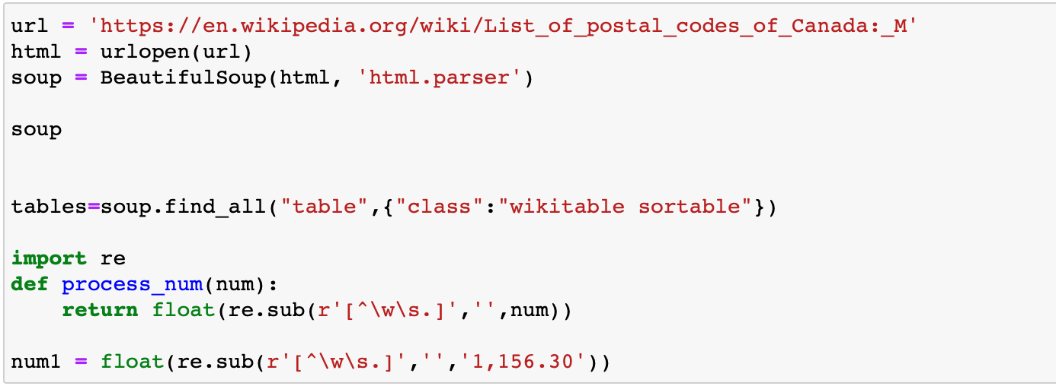Figure 1 Code to scrape data from the wiki page

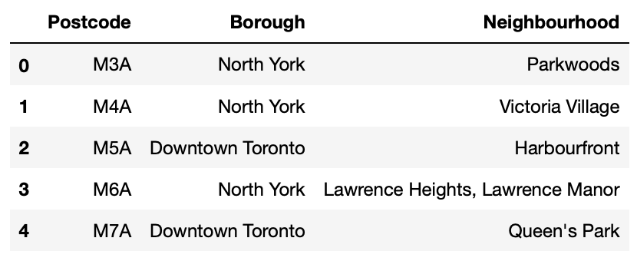

Figure 2: Toronto’s postal codes with neighborhood and borough names

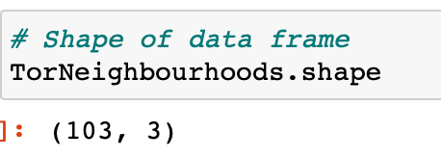

Fig 3 : Total number of neighbourhoods for Canada

Next, we will clean the data to remove “Not Assigned” neighbourhoods and combine the neighbourhoods which have same postcode as given below.We replace the name of the neighbourhoods which are “Not Assigned” with the name of the Borough.We also merge the neighbourhoods which have same Borough. All these are executed with the below set of coding. 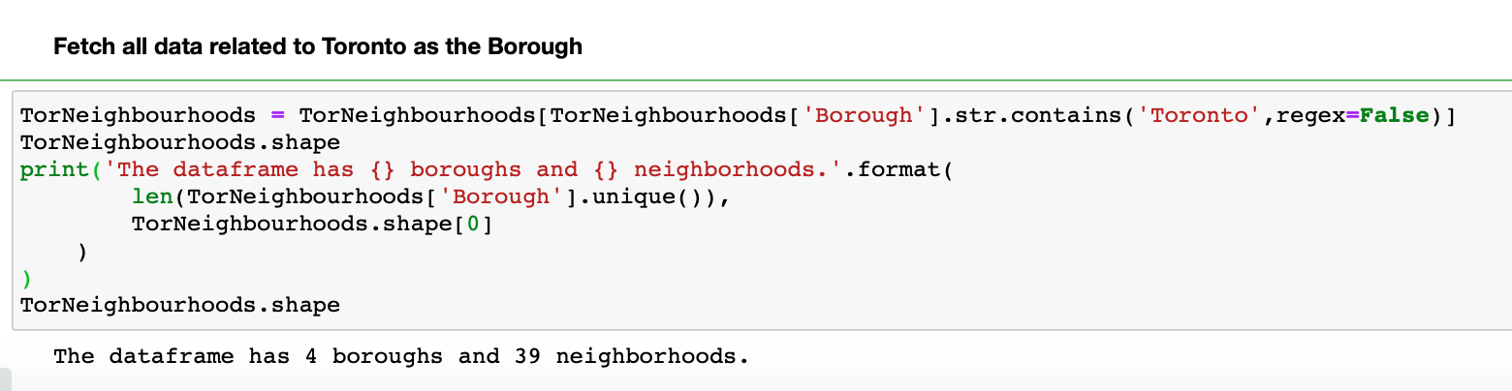

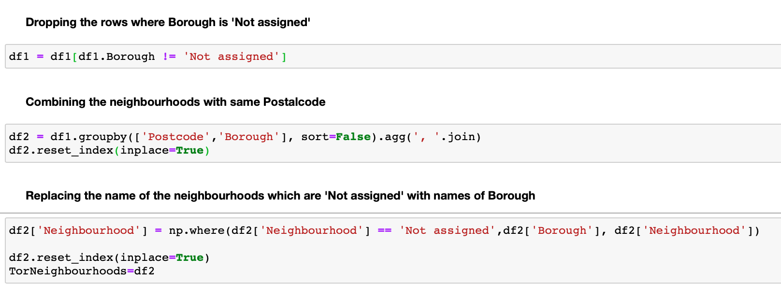

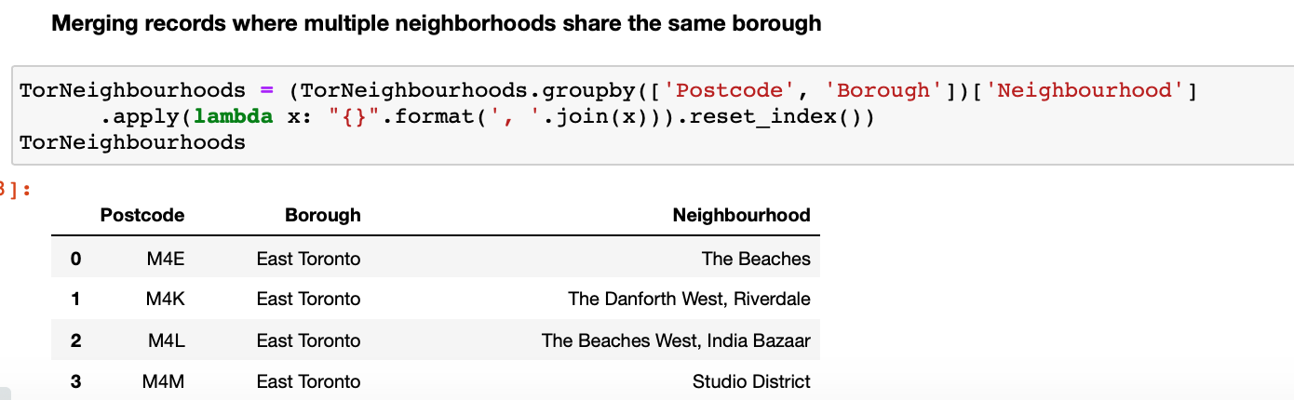

Finally we filter the data having Borough “Toronto”.



Now, We require the Longitudes and Latitudes for each of the neighbourhoods. We read from the CSV file provided for IBM and merge the data with the TorNeighbourhoods dataset to get both neighbourhood data along with the coordinate data.

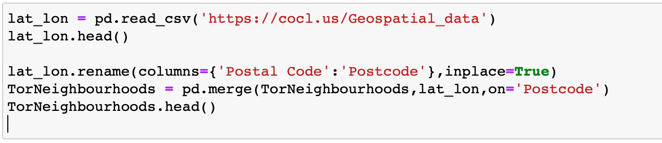

Fig 4 : Code to fetch Longitude and latitude data

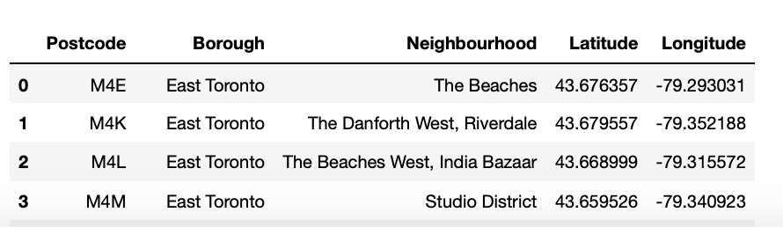

Fig 5 : Resulting dataset with Longitude and Latitude

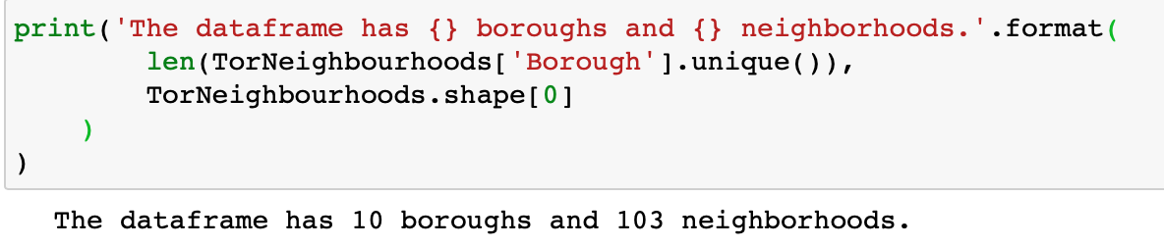

Fig 6 : The dataset has 10 boroughs and 103 neighbourhoods

In the next step, we build the map of all Toronto neighbourhoods. For this , we fetch the longitude and latitude of Toronto and use Folium to draw the map.

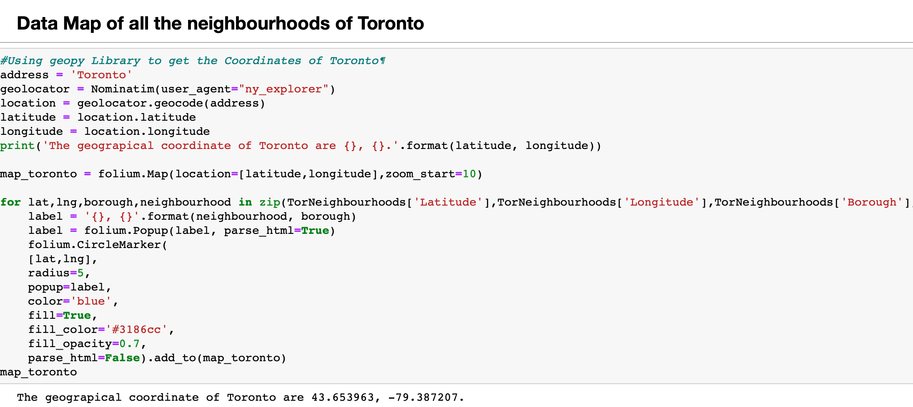

Fig 11 : code to Map neighborhoods

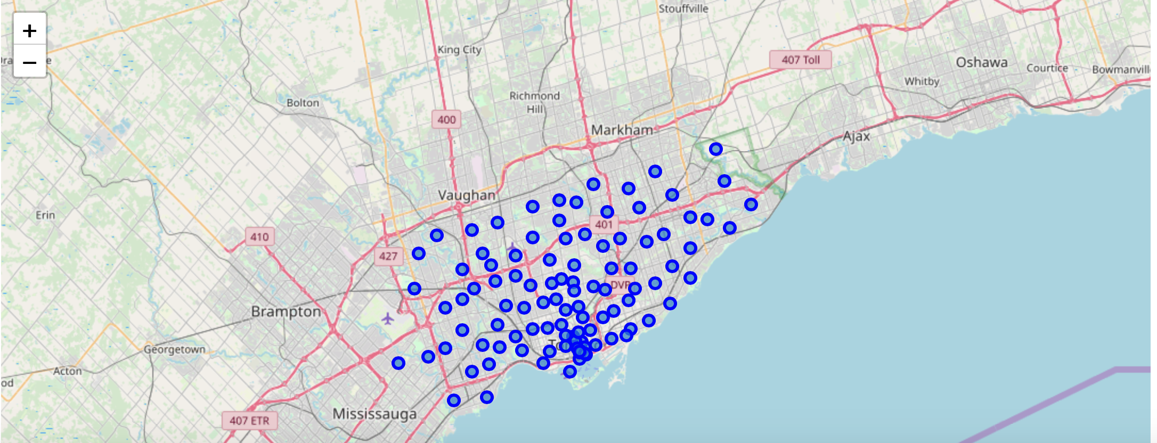

Fig12 : Resulting Map of Toronto Neighbourhoods

**Venue data**

Now, we will retrieve all the Venue data for Toronto neighbourhoods. We exclude the venues such as Building,Office,Bustop etc. Using the function getNearbyVenues, we will fetch the Venue categories for each neighbourhood.Here, we use the Foursquare API to fetch the venues Foursquare which is a popular source of location and venue data. Foursquare API service will be utilized to access and download venues data.

To retrieve data from Foursquare using their API, a URL should be prepared and used to re- quest data related a specific location. An example URL is the following:

https://api.foursquare.com/v2/venues/search?

&client_id=1234&client_secret=1234&v=20180605&

ll=40.89470517661,-73.84720052054902&radius=500&limit=100

where search indicates the API endpoint used, client_id and client_secret are credentials used to access the API service and are obtained when registering a Foursquare developer account, v indicates the API version to use, ll indicates the latitude and longitude of the desired location, radius is the maximum distance in meters between the specified location and the retrieved venues, and limit is used to limit the number of returned results if necessary.

Figure 13 shows the code used to create a function that takes as input the names, latitudes, and longitudes of the neighborhoods, and returns a dataframe with information about each neighbor- hood and its venues.

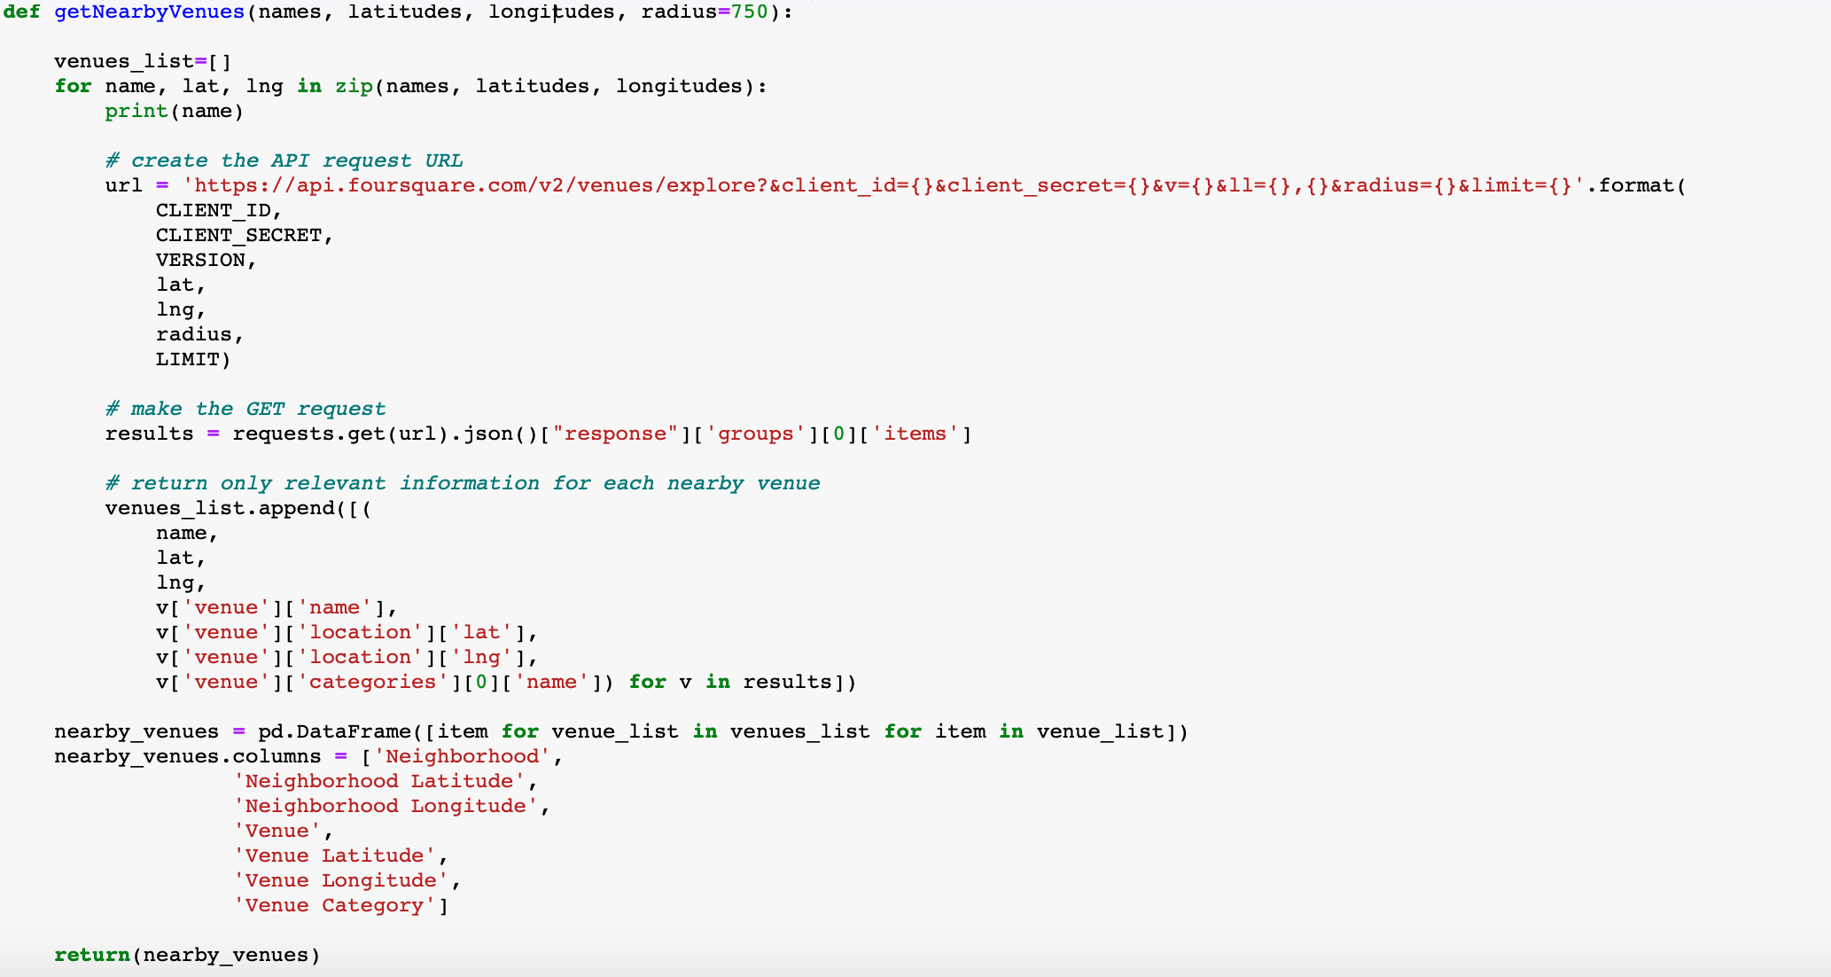

Fig 13 : getNearbyVenues function using Foursquare API.

The resulting Data frame lists the venue, Venue category, Venue latitude and longitudes as given in Fig 14.

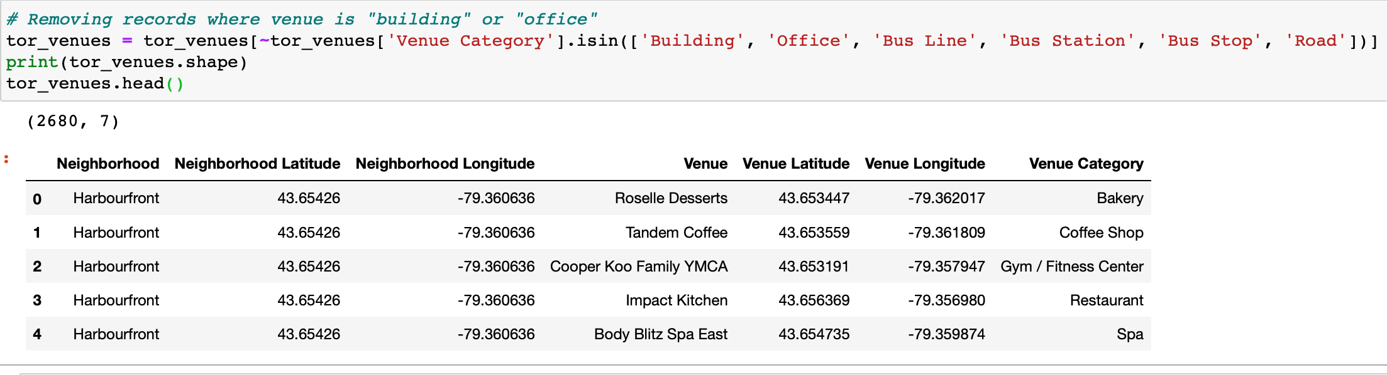

Fig 14 : Venue dataframe for Toronto

Grouping by the neighborhoods will fetch the number of venues in each neighbourhood. Each neighbourhood has different number of venues. For example : Adelaide King,Richmond has 99 neighbourhoods while Berczy park has 100 as shown in fib 15.

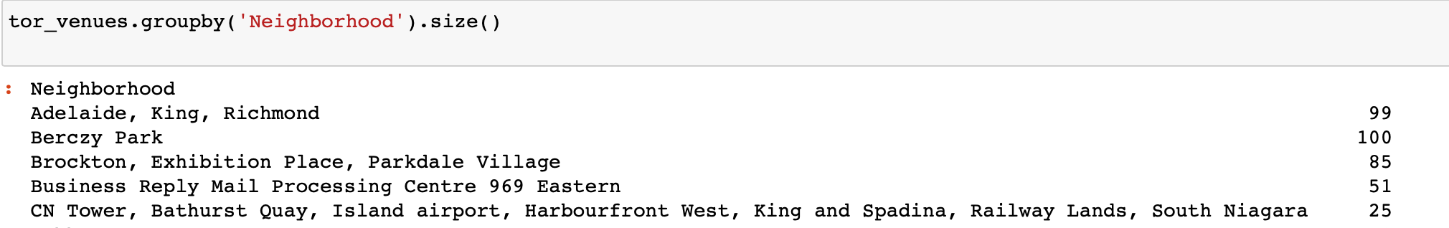

Fig 15: Number of Venues in each neighbourhood

## Neighborhood and Venue data for New York City

**NY Neighbourhoods**

The neighborhood data for New York City was is provided by IBM at the following location <https://cocl.us/new_york_dataset>. . The dataset is a JSON file that specifies the name of each neighborhood, its coordinates—latitude and longitude, its borough. Figure 15 shows the code used to process the JSON file and the resulting dataset with 306 neighbourhoods in Figure 4.The data is stored in a Pandas dataframe NYNeighborhoods

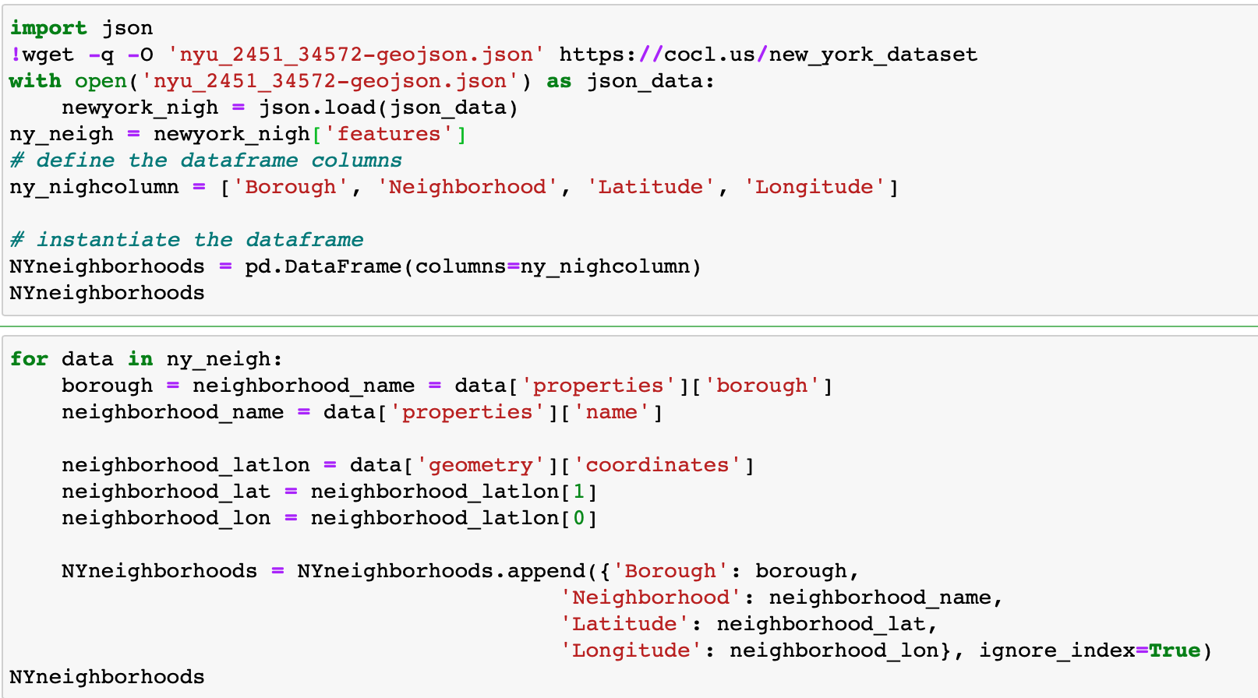

Fig 16 : importing data from Json file

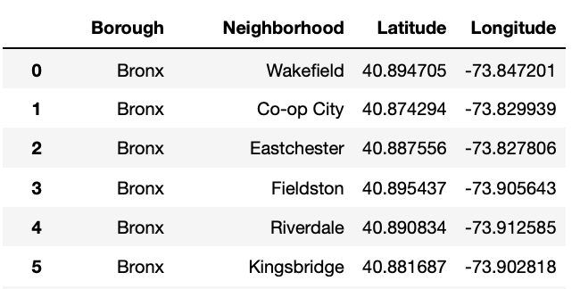

Fig 17 : Dataframe with Latitude and Longitude

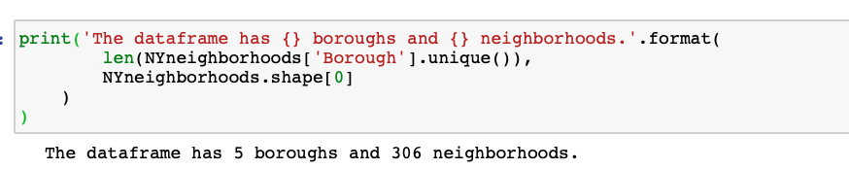

Fig 18: Number of Boroughs and Neighbourhoods

Further, there are neighborhoods that share the same name but are located in different boroughs. To deal with this case, we will include the borough name in the name of these neighborhoods as shown in the below Fig 19

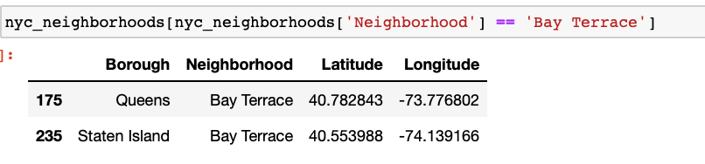

Fig 19 : Neighborhoods that share the same name but are located in different boroughs

"Bay Terrace" neighborhood which is located in "Staten Island" borough will be named "Bay Terrace, Staten Island" and the one in "Queens" will be named "Bay Terrace, Queens" as shown in Fig 20

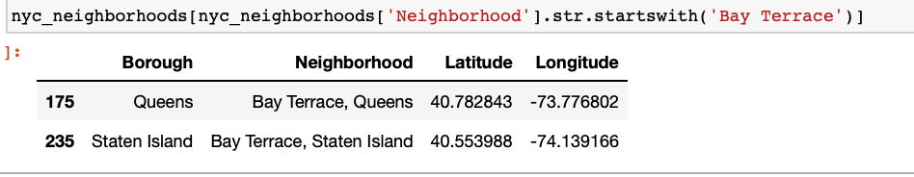

Fig 20 : Borough name appended to neighbourhood names

The below code solves this issue.

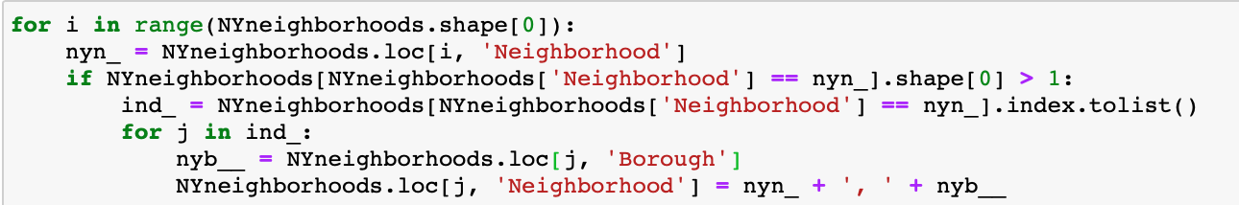

Fig 19 : Code to include borough name in the name of neighbourhoods which share same name but located in different boroughs.

With the help of Folium, we draw the map of New York with all the neighbourhoods.

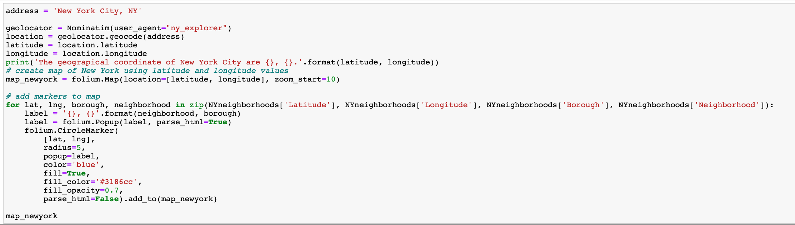

Fig 20 : Code for Data Map for New York neighbourhoods

Having data of the coordinates of NYC neighborhoods, it is possible to draw a map using Folium Python package of NYC and its neighborhoods. Figure 5 shows this map; each blue circle represents the location of one neighborhood.

Figure 21 : A map of NYC and its neighborhoods

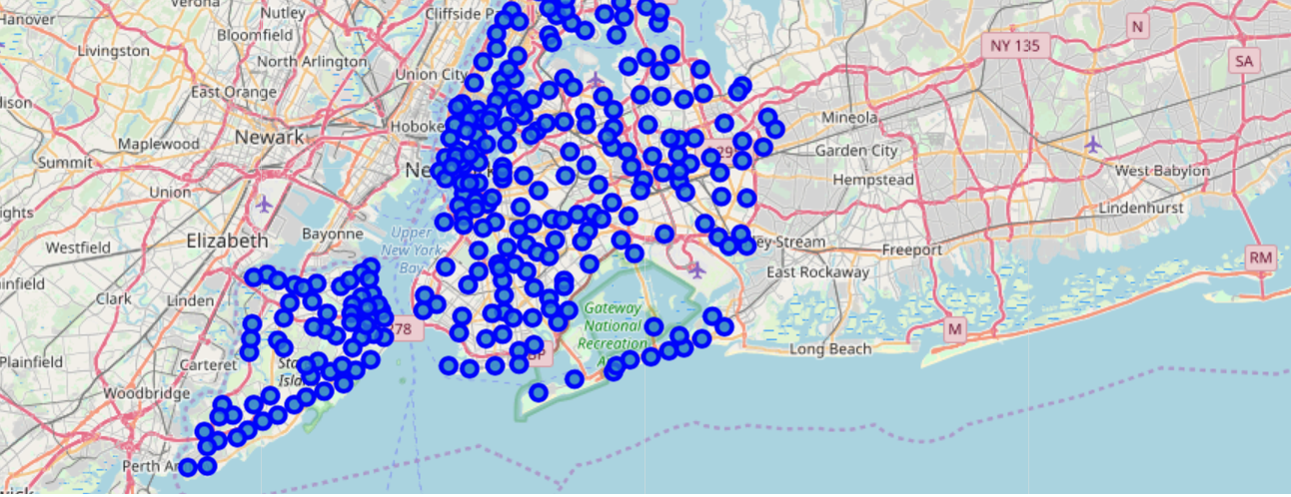

**NY Venues**

For each city, data that describes the venues of its neighborhoods and the categories of these venues is needed. Venues data will be retrieved from Foursquare which is a popular source of location and venue data. Foursquare API service will be utilized to access and download venues data.

To retrieve data from Foursquare using their API, a URL should be prepared and used to re- quest data related a specific location. An example URL is the following:

https://api.foursquare.com/v2/venues/search?

&client_id=1234&client_secret=1234&v=20180605&

ll=40.89470517661,-73.84720052054902&radius=500&limit=100

where search indicates the API endpoint used, client_id and client_secret are credentials used to access the API service and are obtained when registering a Foursquare developer account, v indicates the API version to use, ll indicates the latitude and longitude of the desired location, radius is the maximum distance in meters between the specified location and the retrieved venues, and limit is used to limit the number of returned results if necessary.

Figure 12 shows the code used to create a function that takes as input the names, latitudes, and longitudes of the neighborhoods, and returns a dataframe with information about each neighbor- hood and its venues. It creates an API URL for each neighborhood and retrieves data about the venues of that neighborhoods from Foursquare.

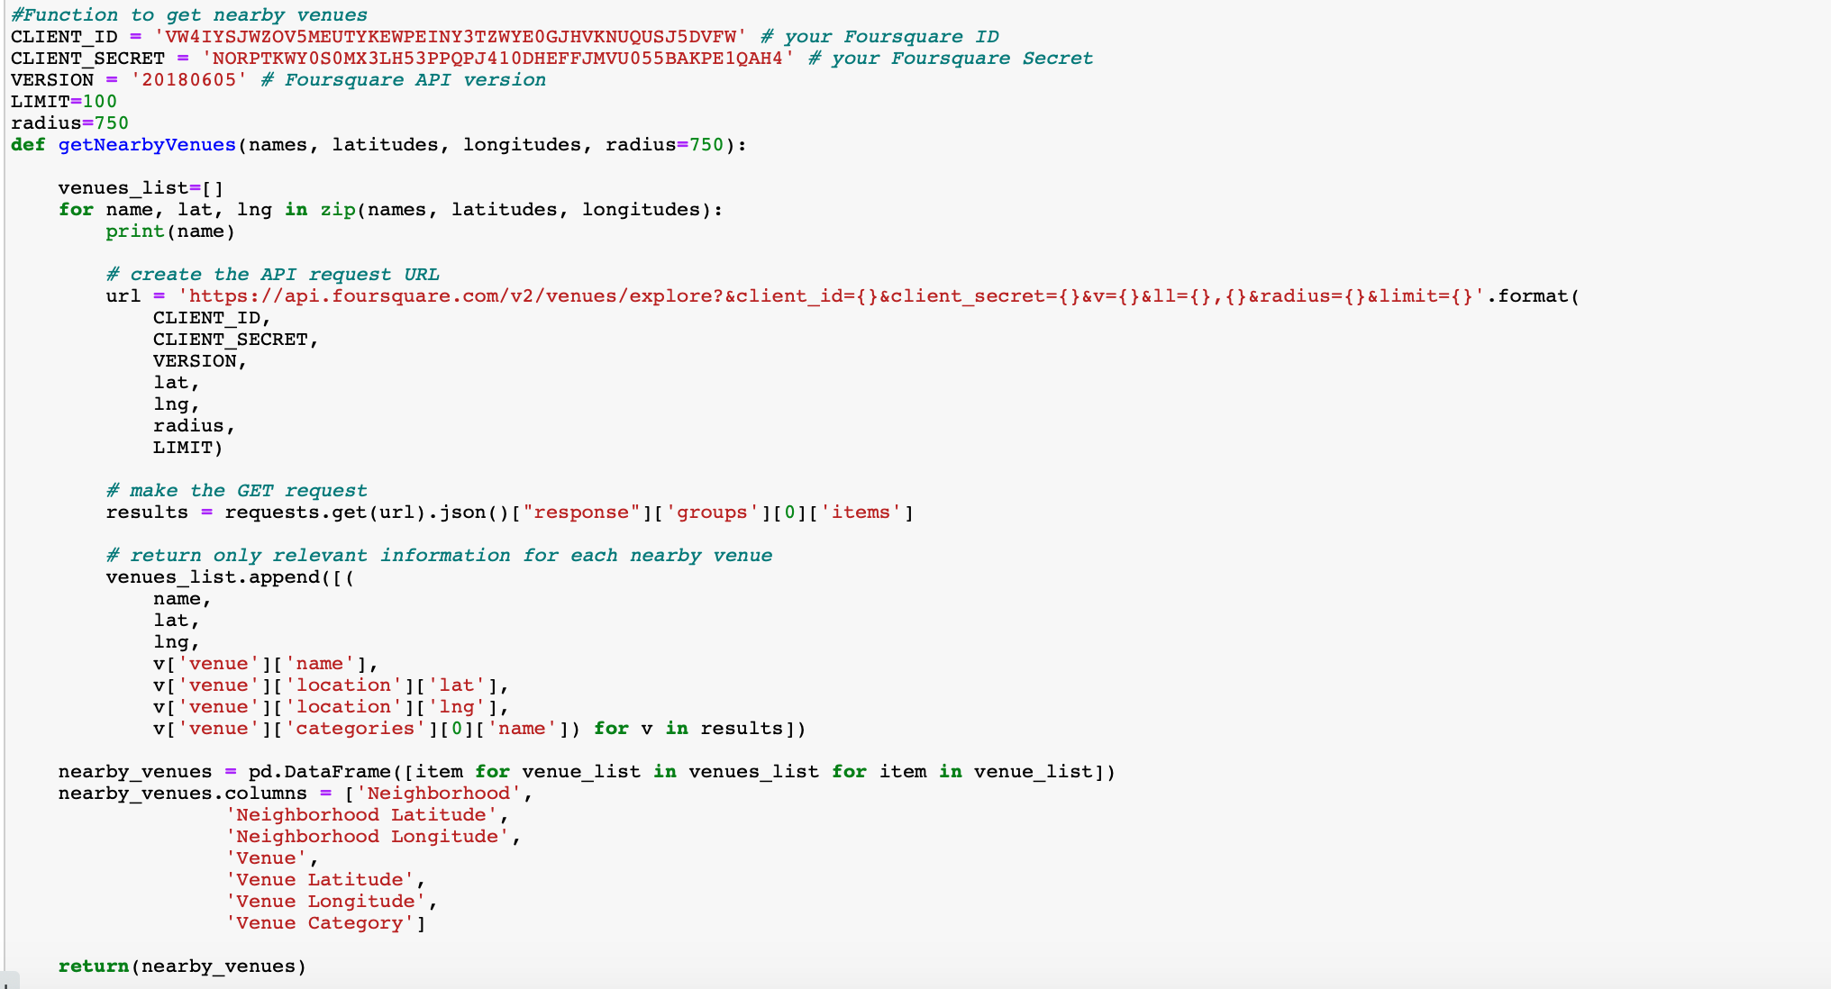

Figure 22 : Code used to build a venues dataframe for a city neighborhoods

This function “getNearbyVenues” in Fig 22 retrieves information about venues in each neighborhood.It takes as input a list of the names of the neighborhoods, a list of their latitudes, and a list of their longitudes.It returns a dataframe with information about each neighborhood and its venues.

After retrieving the venue data, venues whose category is “Building”, “Office”, “Bus Line”, “Bus Station”, “Bus Stop”, or “Road” were excluded because they are not expected to add analyti-cal value in this project.



Fig 23

Using this function with NYC neighborhood data retrieved data about more than 2,33,375 venues in NYC neighborhoods. For each venue, venue name, category, latitude, and lon- gitude were retrieved. The head of the dataframe returned by the function for NYC is shown in Figure 24. We can see that each row in the dataframe contains data about one venue: the venue name, coordinates (latitude and longitude), and category in addition to the neighborhood in which the venue is located and the coordinates of the neighborhood.

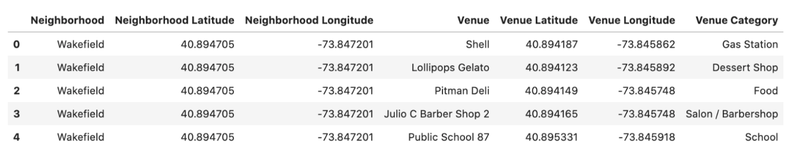

Fig 24 NY dataframe with venue details

Different numbers of venues were found in different neighborhoods: for example, data about 81 venues were returned for Allerton neighborhood, 77 venues for Annadale neighborhood, and 71 venues for Arlington neighborhood as shown in Fig 25.

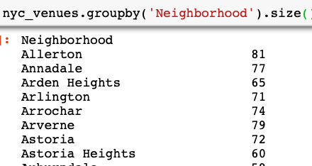

Fig 25 : Number of venues in each neighbourhood

Each venue of them belongs to one of 574 unique categories.

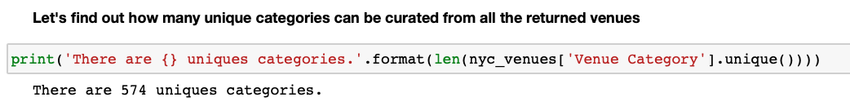

Fig 26 : Unique venue categories